- Explain the functionalities of the network layer.
- The network layer is placed between data link layer and transport layer in the TCP/IP network reference model.
- It is responsible for the source-to-destination delivery of a packet.
- The responsibilities of the network layer are explained below.
  - Logical Addressing:
    - The network layer assigns a unique IP address to each host on the network.
    - This address is used to identify the host and route data packets to it.
  - Routing:
    - The network layer determines the best path for data packets to take from their source to their destination.
    - This is done by using routing protocols, which exchange information about the network topology.
  - Fragmentation and reassembly:
    - The network layer may need to fragment large data packets into smaller packets so that they can be transmitted over a particular link.
    - The packets are then reassembled at the destination host.
  - Error detection and correction:
    - The network layer can detect errors in data packets and request that they be retransmitted.
    - This is done by using checksums, which are calculated over the data packets (Header).
  - Congestion control:
    - The congestion control is the mechanism that prevents the network from becoming overloaded with traffic.
    - This is important to prevent packet loss and delays.
- Describe different network layer protocols.
- IPv4
  - Internet Protocol version 4 (IPv4), is responsible for packetizing, forwarding, and delivery of a packet at the network layer.
- ICMPv4
  - The Internet Control Message Protocol version 4 (ICMPv4) helps IPv4 to handle some errors that may occur in the network-layer delivery.
- IGMP
  - The Internet Group Management Protocol (IGMP) is used to help IPv4 in multicasting.
- ARP
  - The Address Resolution Protocol (ARP) is used to glue the network and data-link layers in mapping network-layer addresses to link-layer addresses.
- Some other protocols such as Internet Protocol version 6 (IPv6) are used to overcome the limitations of the IPv4 and Reverse Address Resolution Protocol (RARP) is used to map hardware address to IP address.
- Explain Three representations of the IPv4 address.
OR
Explain binary, dotted-decimal, and hexadecimal representation of the IPv4 address.
- There are three common notations to represent an IPv4 address:
  - binary notation (base 2)
  - dotted-decimal notation (base 256)
  - hexadecimal notation (base 16)
- Binary notation
  - It is the most basic way to represent an IPv4 address.
  - It is a 32-bit number, which can be written as a string of 8 binary digits (bits). Each bit can have a value of 0 or 1.
  - To make the address more readable, one or more spaces are usually inserted between each octet (8 bits). Each octet is often referred to as a byte.
- Dotted-decimal notation.
  - It is a more human-readable way to represent an IPv4 address.
  - It is a string of four decimal numbers separated by periods (dot ●). Note that because each byte (octet) is only 8 bits, each number in the dotted-decimal notation is between 0 and 255.
- Hexadecimal notation.
  - Each hexadecimal digit is equivalent to four bits.
  - This means that a 32-bit address has 8 hexadecimal digits. This notation is often used in network programming.
- Example of above three representations is given below.
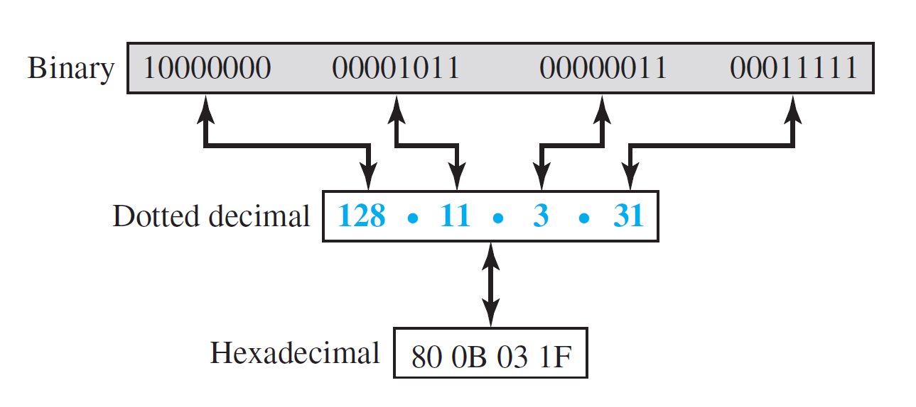
- Explain IPv4 Address
- Any device which wants to communicate with in the computer network, must require an IP address.
- It is the identifier used in the network layer (IP layer) of the TCP/IP protocol suite to identify the connection of each device to the Internet is called the Internet address or IP address.
- It is the address of the connection, not the host or router.
- IPv4 uses 32 bits to define an address, so its address space is 2³², which is equal to more than 4 billion addresses. So more than 4 billion devices could be connected to the Internet using IPv4 addresses.
- It can be represented in three different notations such as binary, dotted-decimal and hexadecimal as shown below.
- It is hierarchical and divided into two parts: Prefix (NET ID) and suffix (HOST ID). These two parts are shown in the following figure.
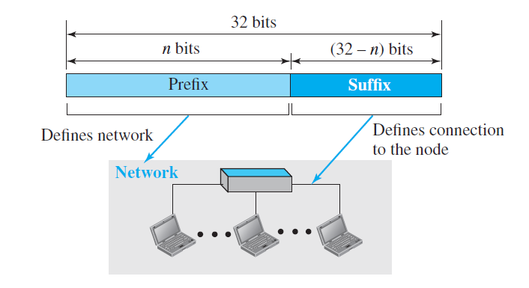
- The prefix defines the networks, and the suffix defines the addresses of the host within the particular network. If the number of prefix bits are n, then the number of suffix bits are 32 – n.
- The IP addressing scheme in which network prefix bits are fix are known as classful IP addressing scheme.
- The IP addressing scheme in which network prefix bits are variable are known as classless IP addressing scheme.
- Example of IPv4 address: 192.168.1.23/24
- In the above example number of prefix bits (NET ID) are 24. So, the number of suffix bits (HOST ID) are 8.
- Explain classful addressing.
- Classful addressing is an IPv4 addressing architecture that divides the address space into five classes: A, B, C, D, and E.
- The first three classes (A, B, and C) are used for network hosts, while class D is reserved for multicasting and class E is reserved for future use.
- Each class occupies some part of the address space.
- The order of bits in the first octet of the IPv4 address determines the classes of the IP address.
- The IPv4 address is divided into two parts:
  - Net ID (Prefix)
  - Host ID (Suffix)
- The network ID identifies the network that the device is connected to, while the host ID identifies the specific device on the network.
- Net ID and Host ID bits for each class is shown below.
 | Byte 1 | Byte 2 | Byte 3 | Byte 4
Class A | NET ID (8) | HOST ID (24)
Class B | NET ID (16) |  | HOST ID (16)
Class C | NET ID (24) |  |  | HOST ID (8)
Class D | MULTICAST ADDRESS
Class E | RESERVED ADDRESS

- Class A
  - IP addresses belonging to class A are assigned to the networks that contain a large number of hosts.
 | Byte 1 |  | Byte 2 | Byte 3 | Byte 4
 | NET ID |  | HOST ID
 | 0 | 7 bits | 24 bits

  - The Net ID is 8 bits long and the Host ID is 24 bits long.
  - The default subnet mask for Class A is 255.0.0.0.
  - class A has a total of
    - 2⁷-2= 126 network ID (Here 2 address is subtracted because 0.0.0.0 and 127.255.255.255 are special address.)
    - 2²⁴ – 2 = 16,777,214 host ID
  - IP addresses belonging to class A ranges from 1.0.0.0 – 126.255.255.255
- Class B
  - IP address belonging to class B is assigned to networks that range from medium-sized to large-sized networks.
 | Byte 1 |  |  | Byte 2 | Byte 3 | Byte 4
 | NET ID |  |  |  | HOST ID
 | 1 | 0 | 14 bits

  - The Net ID is 16 bits long and the Host ID is 16 bits long.
  - The default subnet mask for class B is 255.255.0.0.
  - Class B has a total of:
    - 2¹⁴ = 16384 network address
    - 2¹⁶ – 2 = 65534 host address
  - IP addresses belonging to class B ranges from 128.0.0.0 – 191.255.255.255.
- Class C
  - IP addresses belonging to class C are assigned to small-sized networks.
 | Byte 1 |  |  |  | Byte 2 | Byte 3 | Byte 4
 | 1 | 1 | 0 | 21 bits |  |  | 8 bits

  - The Net ID is 24 bits long and the Host ID is 8 bits long.
  - The default subnet mask for class C is 255.255.255.0.
  - Class C has a total of:
    - 2²¹ = 2097152 network address
    - 2⁸ – 2 = 254 host address
  - IP addresses belonging to class C range from 192.0.0.0 – 223.255.255.255.
- Class D
  - IP address belonging to class D is reserved for multi-casting.
 | Byte 1 |  |  |  |  | Byte 2 | Byte 3 | Byte 4
 | 1 | 1 | 1 | 0 | 28 bits

  - The higher-order bits of the first octet of IP addresses belonging to class D are always set to 1110. The remaining bits are for the address that interested hosts recognize.
  - Class D does not possess any subnet mask.
  - IP addresses belonging to class D range from 224.0.0.0 – 239.255.255.255.
- Class E
  - IP addresses belonging to class E are reserved for experimental and research purposes.
 | Byte 1 |  |  |  |  | Byte 2 | Byte 3 | Byte 4
 | 1 | 1 | 1 | 1 | 28 bits

  - The higher-order bits of the first octet of IP addresses belonging to class E are always set to 1111.
  - Class E does not possess any subnet mask.
  - IP addresses of class E range from 240.0.0.0 – 255.255.255.254.
- Write the advantages and disadvantages of the classful addressing.
- Advantages
  - Simple and easy to understand: Classful addressing is based on a simple and straightforward system of dividing IP addresses into classes. This makes it easy for network administrators to understand and manage IP addresses.
  - Efficient routing: Classful addressing allows routers to quickly and efficiently determine the network and host addresses of devices on the Internet. This is because the class of an IP address can be determined by the first few bits of the address.
  - Compatibility with older devices: Classful addressing is compatible with older network devices that do not support more modern addressing schemes, such as Classless Inter-Domain Routing (CIDR).
- Disadvantages
  - Wastage of IP addresses: Classful addressing can lead to the wastage of IP addresses, especially for small and medium-sized networks. This is because classful addressing assigns a fixed number of IP addresses to each network class, regardless of the actual number of devices on the network.
  - Lack of flexibility: Classful addressing is not very flexible, as it does not allow for the creation of subnets with different sizes. This can make it difficult to efficiently manage IP addresses for networks with a variety of different needs.
  - Incompatibility with CIDR: Classful addressing is incompatible with CIDR, which is the more modern and efficient addressing scheme used on the Internet today.
- Write the difference between classful addressing and classless addressing.
Characteristic | Classful addressing | Classless addressing
IP address allocation | IP addresses are divided into five classes: A, B, C, D, and E. Each class has a different number of bits allocated for the network address and the host address. | IP addresses are divided into networks and subnets. Each subnet can have its own subnet mask, which allows for more efficient use of IP address space.
Flexibility | Less flexible than classless addressing. It is difficult to support networks of different sizes. | More flexible than classful addressing. It is easier to support networks of different sizes.
Efficiency | Less efficient in its use of IP address space. | More efficient in its use of IP address space.

- Explain address depletion.
- The reason that classful addressing has become obsolete is address depletion.
- Since the addresses were not distributed properly, the Internet was faced with the problem of the addresses being rapidly used up, resulting in no more addresses available for organizations and individuals that needed to be connected to the Internet.
- To understand the problem, let us think about class A. This class can be assigned to only 128 organizations in the world, but each organization needs to have a single network (seen by the rest of the world) with 16,777,216 nodes (computers in this single network). Since there may be only a few organizations that are this large, most of the addresses in this class were wasted (unused).
- Class B addresses were designed for midsize organizations, but many of the addresses in this class also remained unused.
- Class C addresses have a completely different flaw in design. The number of addresses that can be used in each network (256) was so small that most companies were not comfortable using a block in this address class.
- Class E addresses were almost never used, wasting the whole class.
- To alleviate address depletion, two strategies were proposed and, to some extent, implemented: subnetting and supernetting.

- Explain classless addressing.
- The IP addressing scheme that does not have fixed prefix length as defined in classful addressing is known as classless addressing. It is also known as classless inter-domain routing (CIDR).
- The Classless addressing removes the "class privilege" from the distribution of addresses. This helps to compensate for the address depletion problem and allows more organizations to get the addresses they need.
- It does not assign addresses based on classes, but instead allows organizations to get the exact amount of address space they need.
- In classless addressing, the whole address space is divided into variable length blocks.
- The prefix in an IP address defines the block (network); the suffix defines the node (device).
- Theoretically, we can have a block of 2⁰, 2¹, 2², . . . , 2³² addresses.
- There are three restrictions for the block assignments in the classless addressing.
  - The number of addresses in the block must be power of 2.
  - All the addresses must be contiguous.
  - The decimal value of the first address must be completely divisible by the number of addresses of the block.
- Unlike classful addressing, the prefix length in classless addressing is variable. We can have a prefix length that ranges from 0 to 32.
- The size of the network is inversely proportional to the length of the prefix. A small prefix means a larger network; a large prefix means a smaller network.
- An address in class A can be thought of as a classless address in which the prefix length is 8. An address in class B can be thought of as a classless address in which the prefix is 16, and so on. In other words, classful addressing is a special case of classless addressing.
- An address in classless addressing can then be represented in CIDR or slash notation as shown in following figure.
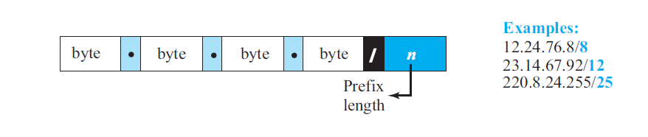
- There are two strategies are used to implement classless addressing: Subnetting and Supernetting.
- The process of dividing one large network two or more than two networks is known as subnetting.
- The process of combining two or more networks into one large network is known as supernetting.
- The following are the advantages of the classless addressing.
  - More efficient use of IP addresses.
  - Improved routing efficiency.
  - Increased flexibility
- The following are the advantages of the classful addressing.
  - Increased complexity.
  - Security risks.
  - Compatibility issues.
- Write the advantages and disadvantages of the classless addressing.
- Advantages
  - More efficient use of IP addresses: Classless addressing allows for networks of any size to be created, and IP addresses can be used more efficiently. This is because classless addressing does not have the fixed prefix length limitations of classful addressing.
  - Improved routing efficiency: Classless addressing allows for more efficient routing of IP packets. This is because routers can use the prefix length to determine which networks an IP packet needs to be forwarded to.
  - Increased flexibility: Classless addressing is more flexible than classful addressing because it allows for networks of any size to be created. This makes it easier to accommodate the changing needs of networks.
- Disadvantages
  - Increased complexity: Classless addressing is more complex than classful addressing because it requires administrators to understand and manage IP addresses and subnet masks.
  - Security risks: Classless addressing can introduce new security risks, such as the possibility of misconfigured subnets and IP address conflicts.
  - Compatibility issues: Classless addressing may not be compatible with older devices and networks that were designed for classful addressing.
- Describe CIDR notation or Slash notations.
- In classless addressing, how to find the prefix length if an address is given. Since the prefix length is not inherent in the address, we need to separately give the length of the prefix.
- In this case, the prefix length, n, is added to the address, separated by a slash. The notation is informally referred to as slash notation and formally as classless interdomain routing or CIDR (pronounced cider) strategy.
- An address in classless addressing can then be represented as shown in Figure.
- In other words, an address in classless addressing does not, per se, define the block or network to which the address belongs; we need to give the prefix length also.
- What is address mask?
- It is a 32-bit binary number which is used to find the network address for any classful or classless IP address.
- It is generally written in dotted-decimal notation or slash notation and it is used in routing process to find the network address for the packet.
- The example is given below.
  - Dotted-decimal: 255.255.255.192
  - Slash notation: /26
- Address mask is inherent in the classful address scheme. The default address mask for class A is 255.0.0.0, class B is 255.255.0.0 and class C is 255.255.255.0
- Address mask is not inherent in the classless addressing. So, it is required to provide the address mask explicitly with the IP address to find the network address.
- Explain sub-netting with suitable example.
- Subnetting is the process of dividing one large network into two or more than two networks.
- It is also defined as the process of borrowing bits from host part of the IP address.
- More levels of hierarchy can be created using subnetting.
- An organization (or an ISP) that is granted a range of addresses may divide the range into several subranges and assign each subrange to a subnetwork (or subnet). Note that nothing stops the organization from creating more levels.
- The subnetworks in a network should be carefully designed to enable the routing of packets.
- Following restrictions must be keep in mind while designing subnetworks.
  - The number of addresses in the subnet must be power of 2.
  - All the addresses must be contiguous.
  - The decimal value of the first address must be completely divisible by the number of addresses of the sub network.
- Example:
  - An organization with the network address 192.168.1.0/24 wants to divide it into four subnetworks, each of has 64 addresses in the sub network.
  - The Network 192.168.1.0/24 has prefix of 24 bits and suffix of 8 bits.
  - To divide this large network into four subnets, 2 bits are required as subnetwork bits. So, /26 will be new prefix for each sub networks.
  - The address range for these four subnetworks will be as follows.
Subnetwork  Number | Address Range
1 | 192.168.1.0 – 192.168.1.63
2 | 192.168.1.64 – 192.168.1.127
3 | 192.168.1.128 – 192.168.1.191
4 | 192.168.1.192 – 192.168.1.255
- Advantages:
  - Reduces broadcast traffic.
  - Improves network security.
  - Increases network flexibility.
  - Improves network performance.
  - Conserves IP addresses.
- Disadvantages:
  - Increased complexity.
  - Reduced network efficiency.
  - Increased cost.
  - Increased security risks.
- Write the advantages and disadvantages of sub netting.
- Advantages:
  - Reduces broadcast traffic: Broadcasts are sent to all devices on a network, which can cause congestion and slow down performance. Subnetting divides a network into smaller subnets, so broadcasts are only sent to devices on the same subnet.
  - Improves network security: Subnetting can be used to isolate different parts of a network from each other, which can help to improve security. For example, you can create a separate subnet for guest users or for sensitive data.
  - Increases network flexibility: Subnetting allows you to customize the size and layout of your network to meet your specific needs. For example, you can create subnets for different departments in an organization or for different types of devices, such as servers and workstations.
  - Improves network performance: Subnetting can help to improve network performance by reducing traffic congestion and improving routing efficiency.
  - Conserves IP addresses: Subnetting allows you to divide a single IP address block into smaller subnets, which can help to conserve IP addresses. This is especially important for organizations with large networks.
- Disadvantages:
  - Increased complexity: Subnetting can make network design and administration more complex. It is important to carefully plan your subnet structure and to have a good understanding of IP addressing and routing.
  - Reduced network efficiency: Subnetting can reduce the overall efficiency of the network by increasing the number of subnets and the amount of routing required.
  - Increased cost: Subnetting may require additional hardware, such as routers and switches.
  - Increased security risks: If subnetting is not implemented correctly, it can create security vulnerabilities. For example, if a subnet is not properly isolated from other subnets, attackers may be able to gain access to sensitive data.
- Explain super-netting with suitable example.
- It is the process of combining the two or more networks into one large network is known as supernetting.
- The process of borrowing bits from the network id of the address is known as the supernetting.
- Super netting is used in route aggregation to reduce the size of routing tables and routing table updates.
- Following restrictions must be keep in mind while designing supernetwork.
  - The number of addresses in the supernet must be power of 2.
  - All the addresses must be contiguous.
  - The decimal value of the first address must be completely divisible by the number of addresses of the supernetwork.
- Example:
  - Suppose we want to Design supernetwork for the four block 192.168.1.0/26, 192.168.1.64/26, 192.168.1.128/26 and 192.168.1.192/26.
  - Currently each block has 64 addresses. So, if we design supernetwork for these blocks, then total address will increase to 256, the prefix bits will decrease from /26 to /24, and our resultant block will be 192.168.1.0/24. The number of routing table entry will be decreased from 4 to 1.

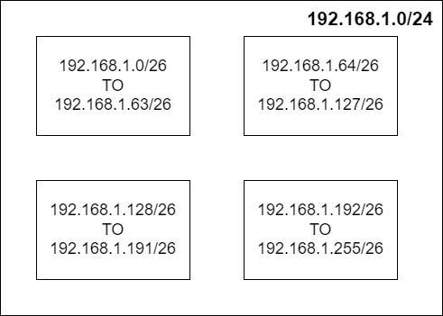

- Write the advantages and disadvantages of supernetting.
- Advantages:
  - Reduced routing table size: Supernetting reduces the number of routing table entries by aggregating multiple smaller networks into a single larger network block. This can improve network performance and reduce router overhead.
  - Improved network performance: Supernetting can improve network performance by reducing the number of routing lookups required to forward packets. This is because routers can use the subnet mask to quickly determine whether a packet is destined for a local network or a remote network.
  - Simplified network management: Supernetting can simplify network management by reducing the number of subnets that need to be configured and maintained. This can be beneficial for large networks with many subnets.
  - More efficient use of IP address space: Supernetting can help to conserve IP address space by allowing multiple smaller networks to be assigned a single larger network block. This can be beneficial for organizations that are running out of IP addresses.
- Disadvantages:
  - Loss of network granularity: Supernetting can reduce network granularity, making it more difficult to implement fine-grained network management, security policies, and traffic control.
  - Increased risk of network failures: If a single supernet experiences a network failure, it can affect multiple smaller networks within that supernet. This can make troubleshooting and isolating network issues more complex.
  - Compatibility issues: Supernetting is not supported by all older network devices and applications. This can cause compatibility issues when implementing supernetting in a mixed-vendor network environment.
- Describe different types of special IPv4 addresses.
- There are five special types of addresses in the address space of the IPv4.

- This-host Address
  - The only address in the block 0.0.0.0/32 is called the this-host address.
  - It is used whenever a host needs to send an IP datagram, but it does not know its own address to use as the source address.
  - It is used in DHCP.
- Limited-broadcast Address
  - The only address in the block 255.255.255.255/32 is called the limited-broadcast address.
  - It is used whenever a router, or a host needs to send a datagram to all devices in a network.
  - The routers in the network, however, block the packet having this address as the destination; the packet cannot travel outside the network.
- Loopback Address
  - The block 127.0.0.0/8 is called the loopback address.
  - A packet with one of the addresses in this block as the destination address never leaves the host; it will remain in the host.
  - Any address in the block is used to test a piece of software in the machine.
- Private Addresses
  - Four blocks are assigned as private addresses: 10.0.0.0/8, 172.16.0.0/12, 192.168.0.0/16, and 169.254.0.0/16.
- Multicast Addresses
  - The block 224.0.0.0/4 is reserved for multicast addresses.
- Explain Network Address Translation
- A technology that can provide the mapping between the private and universal addresses is known as Network Address Translation (NAT).
- The technology allows a site to use a set of private addresses for internal communication and a set of global Internet addresses (at least one) for communication with the rest of the world.
- This technology makes possible to share one global network address among more then one private network address to access the internet.
- The following diagram shows the simple implementation of the NAT.
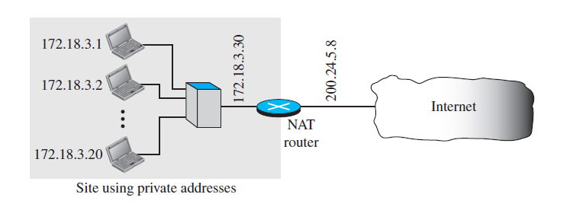
- As the figure shows, the private network uses private addresses. The router that connects the network to the global address uses one private address and one global address. The private network is invisible to the rest of the Internet; the rest of the Internet sees only the NAT router with the address 200.24.5.8.
- The address translation occurs in NAT as shown in the following figure.
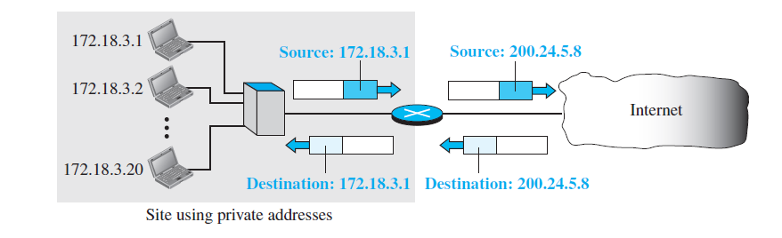
- As shown in the above figure, All of the outgoing packets go through the NAT router, which replaces the source address in the packet with the global NAT address.All incoming packets also pass through the NAT router, which replaces the destination address in the packet (the NAT router global address) with the appropriate private address.
- The NAT router uses translation table to store different types addresses such as IP address and port address for the mapping.
- The following are the advantages of the NAT technology.
  - Conserving IP address space.
  - Improving security
  - Simplifying network administration.
- State the concepts of Forwarding of IP packets based on the destination address.
OR
State the concepts of Forwarding of IP datagrams based on the destination address.
- A forwarding means to place the packet in its route to its destination.
- A forwarding of IP packets based on the destination address is a traditional approach and it most widely used today.
- When a host has a packet to send or when a router has received a packet to be forwarded, it looks at this table to find the next hop to deliver the packet to.
- The following figure shows a simple forwarding module and forwarding table for a router with only three interfaces.
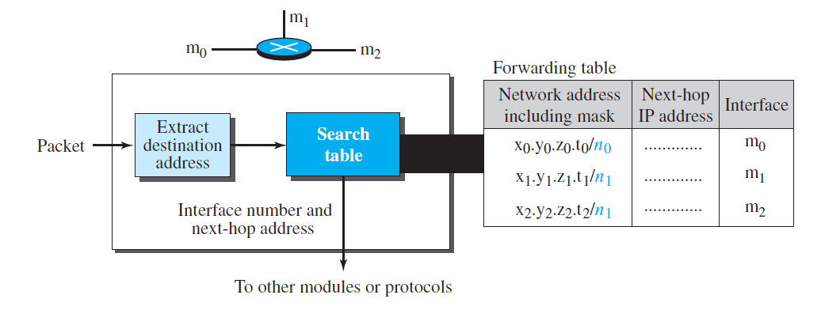
- The job of the forwarding module is to search the table, row by row. In each row, the n leftmost bits of the destination address (prefix) are kept, and the rest of the bits (suffix) are set to 0s. If the resulting address (which we call the network address), matches with the address in the first column, the information in the next two columns is extracted; otherwise, the search continues.
- Normally, the last row has a default value in the first column (not shown in the figure), which indicates all destination addresses that did not match the previous rows.
- The Network diagram and routing table are shown below.
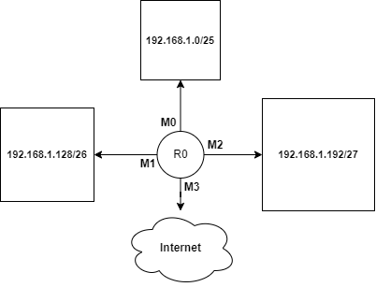
Network Address | Next Hop | Interface
192.168.1.192/27 | -- | M2
192.168.1.128/26 | -- | M1
192.168.1.0/25 | -- | M0
Default route | -- | M4

- As shown in the above figure, the router R0 is connected to three interfaces m0, m1 m2 and m3.
- When a packet arrives whose leftmost 27 bits in the destination address match the bits in the first row in the forwarding table, the packet is sent out from interface m2.
- When a packet arrives whose leftmost 26 bits in the address match the bits in the second row in the forwarding table, the packet is sent out from interface m1, and so on.
- Explain IPv4 Datagram header format.
- The IPv4 datagram header format is shown below.
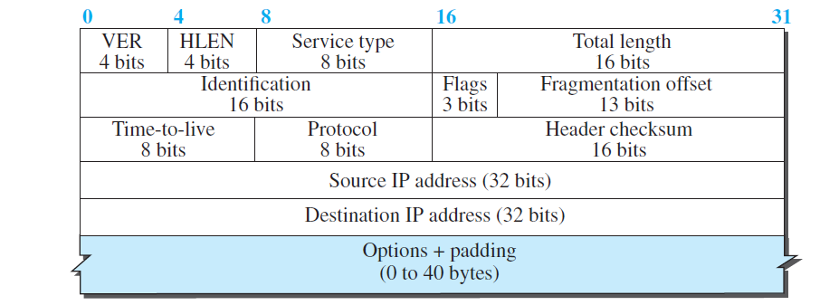
- The header is 20 to 60 bytes in length and contains information essential to routing and delivery.
- The IPv4 datagram header consists of different fields which are explained below.
- Version Number
  - The 4-bit version number (VER) field defines the version of the IPv4 protocol, which, obviously, has the value of 4.
- HLEN
  - This 4-bit header length (HLEN) field defines the total length of the datagram header in 4-byte words.
  - This field is needed because the length of the header is variable (between 20 bytes and 60 bytes).
  - When there are no options, the header length is 20 bytes, and the value of this field is 5 (5 x 4 = 20).
  - When the option field is as its maximum size, the value of this field is 15 (15 x 4 = 60).
- Service Type
  - It is an 8-bit field that is used to specify the desired quality of service (QoS) for the packet. The QoS can include factors such as precedence, delay, throughput, and reliability.
  - Initially it was known as TOS, later it changed to the differentiated services.
- Total Length
  - This 16-bit field defines the total length (header plus data) of the IP datagram in bytes.
Total Length(bytes) = Header Length (Bytes) + Data Length (Bytes)
- Identification, Flags and Fragmentation offset
  - These three fields are related to the fragmentation of the IP datagram when the size of the datagram is larger than the underlying network can carry.
  - Identification Number: IPv4 software assigns unique identification number to every outgoing packet to the network.
  - The 3-bit flags field defines three flags.
    - The leftmost bit is reserved (not used).
    - The second bit (D bit) is called the do not fragment bit, whose bits value decides whether the machine can fragment the packet or not at the time of fragmentation.
    - The third bit (M bit) is called the more fragment bit, whose value decide the current fragment is last or not at the time or reassembly.
    - The 13-bit fragmentation offset field shows the relative position of this fragment with respect to the whole datagram.
- Time-to-live
  - It decides the lifetime of the datagram in the network.
  - This field was originally designed to hold a timestamp, which was decremented by each visited router. The datagram was discarded when the value became zero.
  - Today, this field is used mostly to control the maximum number of hops (routers) visited by the datagram.
- Protocol
  - It stores the protocol number that uses the service of IP protocol.
- Header checksum
  - It is a 16-bit field that is used to store the checksum value of the header only.
- Source IP address, Destination IP address
  - These 32-bit source and destination address fields define the IP address of the source and destination respectively.
  - The value of these fields must remain unchanged during the time the IP datagram travels from the source host to the destination host.
- Options
  - A datagram header can have up to 40 bytes of options.
  - Options can be used for network testing and debugging.
  - There are one-byte and multi-byte options.
  - It is not the required part of the IPv4 datagram header.
- State the concepts of the fragmentation in IPv4.
- The process of dividing a datagram(packet) into two or more smaller datagrams (called fragments) based on the MTU (Maximum Transfer Unit) size of the underlying physical network is known as fragmentation.
- A datagram can be fragmented by the source host or any router in the path.
- The reassembly of the datagram, however, is done only by the destination host.
- The fragmented datagram can travel through different routes.
- There are three fields in an IP datagram are related to fragmentation: identification, flags (D & M), and fragmentation offset.
- When a datagram is fragmented, the value in the identification field is copied into all fragments. In other words, all fragments have the same identification number.
- D bit is called the do not fragment bit. If its value is 1, the machine must not fragment the datagram. If its value is 0, the datagram can be fragmented if necessary.
- M bit is called the more fragment bit. If its value is 1, it means the datagram is not the last fragment; there are more fragments after this one. If its value is 0, it means this is the last or only fragment.
- The 13-bit fragmentation offset field shows the relative position of this fragment with respect to the whole datagram.
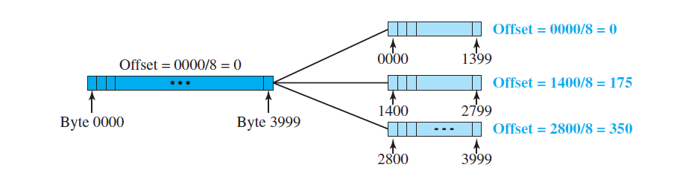
- As shown in the above figure, Consider the size of the MTU field is 1420. So, A datagram with a data size of 4000 bytes fragmented into three fragments. The bytes in the original datagram are numbered 0 to 3999.
- The first fragment carries bytes 0 to 1399; The M bit is 1 and offset for this datagram is 0/8 = 0.
- The second fragment carries bytes 1400 to 2799; the M bit is 1 and offset value for this fragment is 1400/8 = 175.
- Finally, the third fragment carries bytes 2800 to 3999. The M bit is 0 and offset value for this fragment is 2800/8 = 350.
- The identification number is same for all three fragments.
- The expanded view of the above figure is shown below.
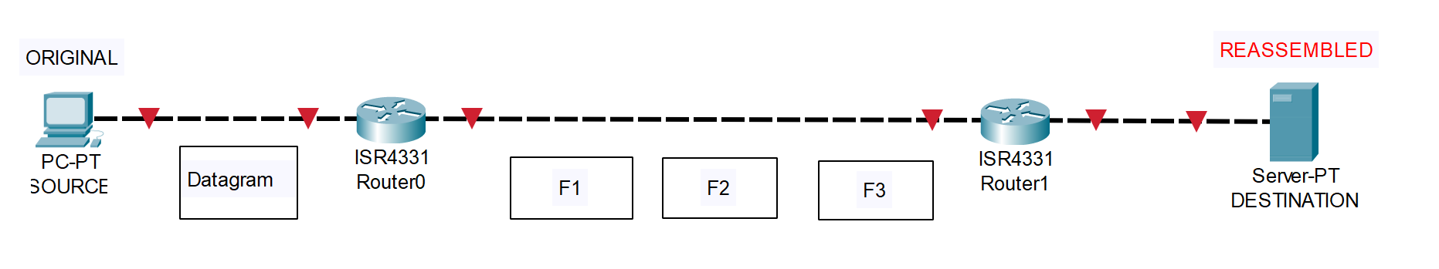
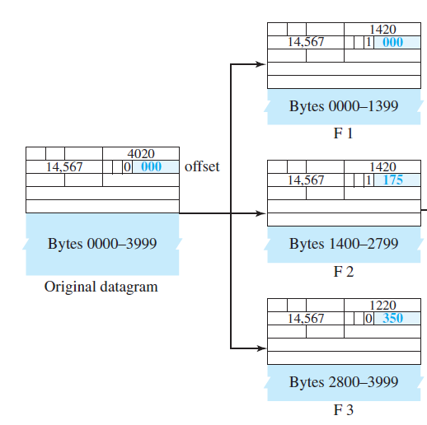
- The destination host reassembles the original datagram from the fragments received (if none of them is lost) using the following strategy:
  - The first fragment has an offset field value of zero.
  - Divide the length of the first fragment by 8. The second fragment has an offset value equal to that result.
  - Divide the total length of the first and second fragment by 8. The third fragment has an offset value equal to that result.
  - Continue the process. The last fragment has its M bit (more bit) set to 0.
- Describe options fields of the IPv4 datagram format.
- The header of the IPv4 datagram is made of two parts:
  - a fixed part
  - a variable part.
- The fixed part is 20 bytes long.
- The variable part comprises the options that can be a maximum of 40 bytes.
- Options, as the name implies, are not required for a datagram. They can be used for network testing and debugging.
- Options are divided into two broad categories: single-byte options and multiple-byte options.

- Single -Byte Options
  - There are two single-byte options.
    - No Operation
      - A no-operation option is a 1-byte option used as a filler between options.
    - End of Option
      - An end-of-option option is a 1-byte option used for padding at the end of the option field.
- Multiple-Byte Options
  - There are four multiple-byte options.
  - Record Route
    - A record route option is used to record the Internet routers that handle the datagram.
  - Strict Source Route
    - A strict source route option is used by the source to predetermine a route for the datagram as it travels through the Internet.
    - If a datagram specifies a strict source route, all the routers defined in the option must be visited by the datagram. A router must not be visited if its IPv4 address is not listed in the datagram.
    - If the datagram visits a router that is not on the list, the datagram is discarded, and an error message is issued.
    - If the datagram arrives at the destination and some of the entries were not visited, it will also be discarded, and an error message issued.
  - Loose Source Route
    - A loose source route option is similar to the strict source route, but it is less rigid.
    - Each router in the list must be visited, but the datagram can visit other routers as well.
  - Timestamp
    - A timestamp option is used to record the time of datagram processing by a router.
- Describe security of IPv4 datagram.
- The IPv4 protocol, as well as the whole Internet, was started when the Internet users trusted each other. No security was provided for the IPv4 protocol.
- Today, however, the situation is different; the Internet is not secure anymore.
- There are three security issues that are particularly applicable to the IP protocol:
  - packet sniffing,
  - packet modification,
  - IP spoofing.
- Packet Sniffing
  - An intruder may intercept an IP packet and make a copy of it.
  - Packet sniffing is a passive attack, in which the attacker does not change the contents of the packet. This type of attack is very difficult to detect because the sender and the receiver may never know that the packet has been copied.
  - Although packet sniffing cannot be stopped, encryption of the packet can make the attacker’s effort useless.
- Packet Modification
  - The second type of attack is to modify the packet.
  - The attacker intercepts the packet, changes its contents, and sends the new packet to the receiver. The receiver believes that the packet is coming from the original sender.
  - This type of attack can be detected using a data integrity mechanism.
- IP Spoofing
  - An attacker can masquerade as somebody else and create an IP packet that carries the source address of another computer.
  - This type of attack can be prevented using an origin authentication mechanism.
- IPSec protocol, which is used in conjunction with the IP protocol, creates a connection-oriented service between two entities in which they can exchange IP packets without worrying about the three attacks discussed above.
- Write a short note on ICMPv4 protocol.
- The IP protocol does not have a mechanism for host and management queries.
- A host sometimes needs to determine if a router or another host is alive. And sometimes a network manager needs information from another host or router.
- The Internet Control Message Protocol version 4 (ICMPv4) has been designed to compensate for the above two deficiencies.
- It is a companion to the IP protocol.
- ICMP itself is a network-layer protocol. However, its messages are not passed directly to the data-link layer as would be expected. Instead, the messages are first encapsulated inside IP datagrams before going to the lower layer. When an IP datagram encapsulates an ICMP message, the value of the protocol field in the IP datagram is set to 1 to indicate that the IP payroll is an ICMP message.
- ICMP uses different types of messages to report and manage different types of errors.
- These messages are divided into two broad categories:
  - error-reporting messages
  - query messages.
- The error-reporting messages report problems that a router or a host (destination) may encounter when it processes an IP packet.
- The query messages, which occur in pairs, help a host or a network manager get specific information from a router or another host.
- Explain different types of ICMPv4 messages.
- ICMP messages are divided into two broad categories:
  - error-reporting messages
  - and query messages.
- The error-reporting messages report problems that a router or a host (destination) may encounter when it processes an IP packet.
- The query messages, which occur in pairs, help a host or a network manager get specific information from a router or another host.
- Error reporting messages.
  - Since IP is an unreliable protocol, one of the main responsibilities of ICMP is to report some errors that may occur during the processing of the IP datagram.
  - ICMP does not correct errors, it simply reports them. Error correction is left to the higher-level protocols.
  - Error messages are always sent to the original source because the only information available in the datagram about the route is the source and destination IP addresses.
  - There are five different types of error reporting messages.
    - Destination Unreachable
      - The most widely used error message is the destination unreachable (type 3).
      - This message uses different codes (0 to 15) to define the type of error message and the reason why a datagram has not reached its final destination.
    - Source Quench
      - The source quench (type 4) message, which informs the sender that the network has encountered congestion and the datagram has been dropped; the source needs to slow down sending more datagrams.
    - Redirection Message
      - The redirection message (type 5) is used when the source uses a wrong router to send out its message.
      - The router redirects the message to the appropriate router, but informs the source that it needs to change its default router in the future.
    - Time Exceed Message
      - When the TTL value becomes 0, the datagram is dropped by the visiting router and a time exceeded message (type 11) with code 0 is sent to the source to inform it about the situation.
      - The time-exceeded message (with code 1) can also be sent when not all fragments of a datagram arrive within a predefined period of time.
    - Parameter Problem
      - A parameter problem message (type 12) can be sent when either there is a problem in the header of a datagram (code 0) or some options are missing or cannot be interpreted (code 1).
  - Query messages.
    - Query messages are used to probe or test the liveliness of hosts or routers in the Internet, find the one-way or the round-trip time for an IP datagram between two devices, or even find out whether the clocks in two devices are synchronized.
    - There are two different types of query messages.
      - Echo request and Echo Reply
      - The timestamp request and the timestamp reply
    - Echo request and Echo reply.
      - The echo request and the echo reply pair of messages are used by a host or a router to test the liveliness of another host or router.
      - A host or router sends an echo request message to another host or router; if the latter is alive, it responds with an echo reply message.
    - The timestamp request and the timestamp reply
      - The timestamp request and the timestamp reply pair of messages are used to find the round-trip time between two devices or to check whether the clocks in two devices are synchronized.
- Draw and label sketch of ICMPv4 packet format.
- The ICMPv4 packet format is shown below.

Type (1 byte) | Code (1 byte) | Checksum (2 Bytes)
Optional Data Section (variable length)

- Type: An 8-bit field that specifies the type of ICMP message.
- Code: An 8-bit field that provides additional information about the ICMP message type.
- Checksum: A 16-bit checksum that is used to verify the integrity of the ICMP packet.
- Data Section: An optional section that contains additional data, such as the original IP header of the packet that caused the ICMP message to be sent.

